**ParentAccess Instructions (Student)**

The first time you enter the website, you will need to create an account.

Welcome to the new ProgressBook© Parent Access grade book. Follow the instructions on this sheet to view your classroom progress and to create a login for your assignments, grades, etc. **Please save this paper for future reference.**

**Student’s name «Firstname» «LastName»** **Registration Key «RegistrationKey»**

**How to create your account**

**Step 1**

Go to <https://parentaccess.swoca.net/Home/District> and select the school district from the list.

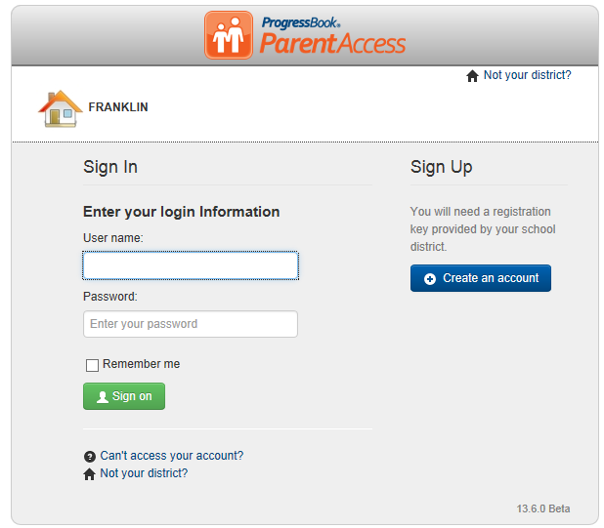

**Step 2**

**Select Student**

**Complete the Student Information**

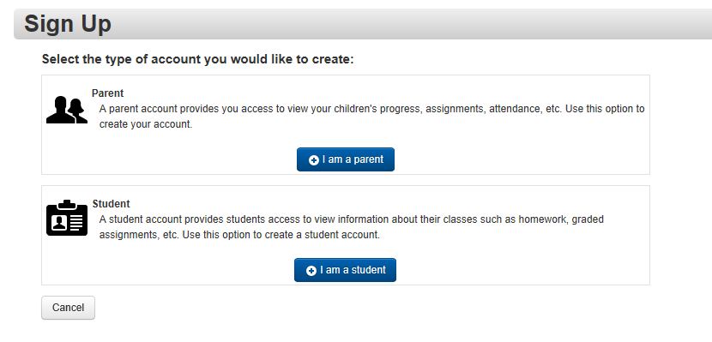

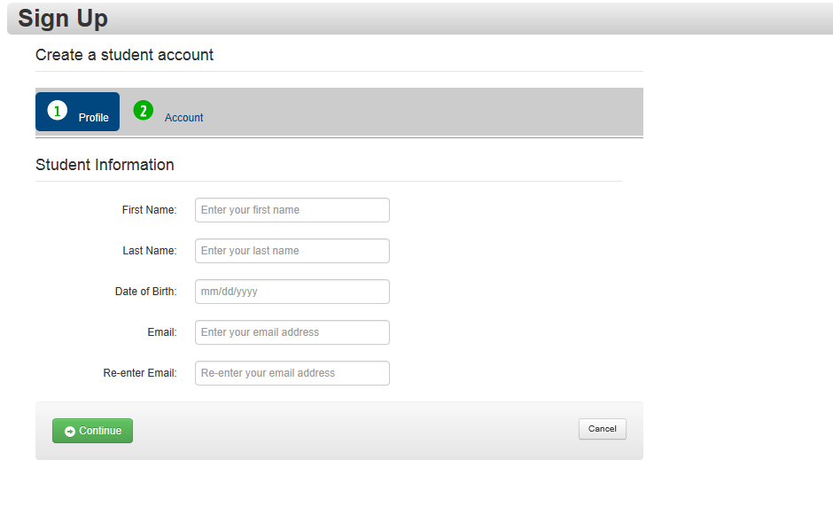

**Step 3**

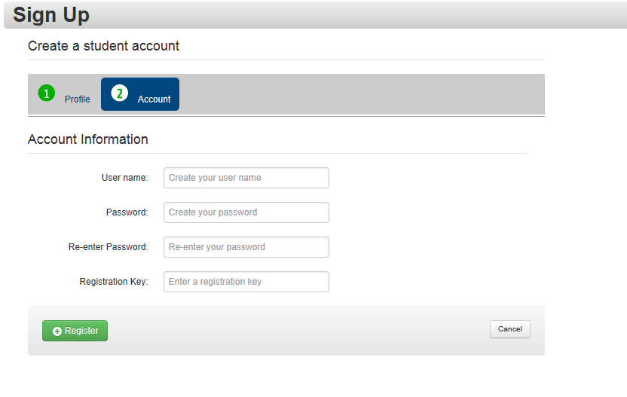

User Name—6-50 characters

Password--must contain at least 1 letter, 1 number, 8-50 characters, case sensitive, and cannot match the username

***Remember your User Name and Password. You will need this information to log into ProgressBook****©****.***

